20. Implementing Distributed Database System and Handling Data Partitioning.
Create Database:
CREATE DATABASE dbmt2;
use dbmt2;
Create Tables:
CREATE TABLE Student(
student_id INT PRIMARY KEY,
name VARCHAR(50),
city VARCHAR(50),
department VARCHAR(50));
CREATE TABLE Course(
course_id INT PRIMARY KEY,
course_name VARCHAR(50),
credits INT);
Insert Sample Data:
INSERT INTO Student VALUES
(1,'Minal','Delhi','Mathematics'),
(2,'Rahul','Mumbai','Computer science'),
(3,'Pranav','Amaravati','Physics'),
(4,'Amol','Mumbai','Physics');
Select*from Student;

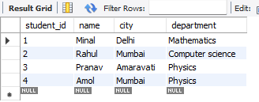

Horizontal Partitioning:
CREATE TABLE Student_Mumbai AS
SELECT*FROM Student
WHERE city='Mumbai';
CREATE TABLE Student_Delhi AS
SELECT*FROM Student
WHERE city='Delhi';
Vertical Partitioning:
CREATE TABLE Student_Personal AS
SELECT student_id ,name city
FROM Student;
CREATE TABLE Student_Academic AS
SELECT Student_id ,department
FROM Student;
Check Storage Engines:
SHOW ENGINES;
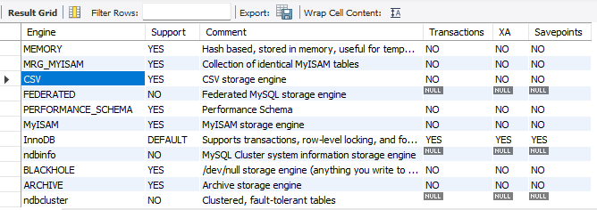

Combine Horizontally Partitioned Tables:
SELECT*FROM Student_Mumbai
UNION
SELECT*FROM Student_Delhi;

